Hardware: Output
hw_output.php — Hardware

Output


Giving the user feedback
The purpose of output is so that the user can get feedback about what the computer is doing.
The very first computers only used flashing lights, sounds and printed results on paper as feedback.
They were not interactive.
The first step towards making computers the useful tools that they are today was getting them to provide immediate, changeable output - in the form of text on a screen.
With the arrival of the monitor, suddenly the user of the computer could do something (type a word, press a key) and get immediate,interactive feedback on what the computer did in response.
This changed computing and was the first step in making it accessible and useable for everyone.
Many steps have been taken along the path of developing output since then…
The types of output devices determine not only the type of feedback the computer can provide - but also what the computer can be used for.
Explore them in the dropdowns below:
The screen / monitor / display

Immediate, changeable feedback that makes interactivity possible
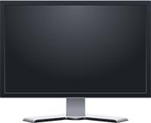
Screens are the most important type of output device. In fact, they are so important that some computing devices (smartphones, tablets) seem to be nothing much more than a screen.
At first glance screens seem simple: They are rectangles of glass that display text and images in glorious colour.
BUT! There are so many different types of screens out there and each one seems to have different technical specifications. Obviously these specifications tell us something about how the screen works - and as an IT professional you will need to know what they mean - and how they affect your choice when buying a monitor.
Before we start looking at these specification note that they also apply to TVs - and that a TV can also be used as a computer monitor provided your computer has an HDMI output.
The important concepts to know are:
Screen Specs
Screen Size
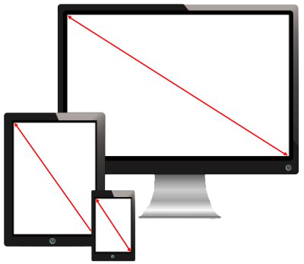
Screen size is measured diagonally from the top left corner to the bottom right corner of the screen.
It is measured in inches (thats what 27" means - 27 inches) - mainly because the Americans do not use the decimal system for measurement.
Screen size has got nothing to do with resolution. It just describes the physical size of the screen.
Screen size typically ranges from 19" - 27" for monitors but can go much bigger for TVs.
Back to the top of this Panel
Refresh Rate
This video shows the difference between 60 Hz and 120 Hz refresh rates.
The refresh rate is how often the monitor redraws the screen.
The refresh rate is measured in Hz (Hertz).
A 60 Hz screen redraws its display 60 times a second.
Most monitors operate at 60 Hz but you can get monitors that operate at 120 Hz, 144 Hz or 240 Hz.
The higher the refresh rate the smoother the visual experience is for the user.
A faster refresh rate also means that less likely you are to see the screen flicker, jitter and tear (watch the video comparing refresh rates to see what is meant by this).
That said, 60 Hz is fast enough for most people using their computer for general productivity tasks such as word processing, web browsing, etc.
Back to the top of this Panel
LED vs LCD vs OLED
This video explains the difference between how LCD, LED and OLED displays work.
This is about how the screen generates light to create the image that you see.
Both LCD (Liquid Crystal Display) and (Light Emitting Diode) screens work with a white backlight shining through filtered (red, green and blue) layers. This means that for most screens there is a white light in the background that sines through 'stuff' that creates the coloured image that you see. The 'stuff' is explained below…
In LCD screens the backlight comes from neon tubes.
In LED screens the backlight comes from steps of white LED lights.
The light shines through a filtered grid of sub-pixels.
The filters are what give the sub-pixels their red, green or blue colour.
Each pixel that you see is made up from a group of these three coloured 'sub pixels' together.
Combining the red, green and blue is what allows the pixel to display different colours.
The sub-pixels themselves can be opaque (let no light through) or transparent (let all the light through).
This is what makes the pixel light or dark.
This design does 'leak' light and this is the reason neither of these technologies given you a perfect black.

The OLED difference
OLED (Organic Light Emitting Diode) does not need a backlight because each pixel glows by itself.
OLED can produce very bright colours and very deep, rich blacks.
OLED is much more expensive and is found mainly on smartphones and smartwatches - it is rare to see it on tablets, monitors or TVs.
Back to the top of this Panel
Aspect Ratio
Aspect ratio describes the shape of the screen in terms of the relationship between the width and height of the screen.
If you see figures such as 4:3 or 16:9 in the description of a screen then you are seeing the aspect ratio.
Older computer monitors (and TVs) had a 4:3 aspect ratio. Most modern monitors tend to have a wider aspect ratio such as 16:9. or 16:10
Wider aspect ratios are better suited to watching movies(21:9) or HD TV (16:9) - and allow more space on the screen for placing application windows side by side when multi-tasking.
This is why most modern computer monitors have wider aspect ratios than the older almost square 4:3 ratio monitors.
Back to the top of this Panel
Resolution
Resolution describes the number of pixels on the screen.
The measurement is usually expressed as the number of horizontal pixels x the number of vertical pixels.
Typical resolutions are:
Older Formats:
300 x 240 (CGA)
640 x 480 (EGA)
800 x 600 (VGA)
1024 x 768 (XGA)
Many web sites are still designed around this resolution because it is a good compromise between the higher resolutions of monitors and the limits of mobile device screen sizes.
Newer Formats:
1280 x 720 (HD)
1920 x 1080 (Full HD)
1920 x 1200
2560 x 1440 (Quad HD)
3840 x 2160 (4K)
5120 × 2880 (5K)
This is the highest resolution for monitors in 2018 - You get a 5K iMac from Apple and some third party 5K monitors.
7680 × 4320 (8K)
You get a few rare and expensive 8K TVs (we are talking prices well over R100 000).
Your experience of resolution is something much more than this measurement. It is shaped by a combination of factors:
One important factor is the size of the screen.
Think about it: you have 1920 x 1080 pixels.
If the physical size of the screen is 21" then each pixel is physically smaller than if you fit the same 1920 x 1080 pixels into a 50" screen - the pixels have to be bigger to fill the larger space.
Your experience is also affected by how close you are to the screen. With the 50" screen you might sit 3m away from the screen. At that distance you don't see the individual pixels so clearly. But if you sat 1m or closer to that same 50" screen the pixels would seem much larger and the picture much less sharp.
Your experience is also affected by how close you are to the screen.
With the 50" screen you might sit 3m away from the screen. At that distance you don't see the individual pixels so clearly. But if you sat 1m or closer to that same 50" screen the pixels would seem much larger and the picture much less sharp.
This video may be a bit long but it combines explanations of size, aspect ratio, resolution and a few quirky facts on human vision. It also presents the creator's bias against 4K…
PS: I disagree with the guy about 4K in a sense. 4K might be of dubious value for TVs BUT it is awesome as a computer monitor for work.
I have a three monitor setup: two 27" QHD monitors and one 27" 4K monitor. The resolution of the 4K monitor makes working with graphics, photo editing, video, 3D etc. a dream and a pleasure. That extra screen real estate makes a BIG difference for serious work.
For games and video - not so much.
Back to the top of this Panel

Data / Video Projectors
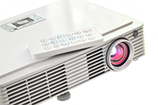
Another video display device is the Data Projector.
Older versions of this device combined a small LCD panel with a very bright backlight and a lens that allows you to focus the image on a distant screen.
Newer projectors use a technology called DLP to create the projected image. DLP combines a micro mirror with a spinning colour wheel to create the image. You don't need to know how this works, but if you are curious then you can find an explanation in the video links section.
DLP produces a higher quality image at a lower price than the older LCD type projectors.
The highest quality, most expensive type of projector uses Laser lights to draw the image.
The further the projector is from the screen the larger (but dimmer) the projected image will be.
Most cheap (affordable - below R5 000) data projectors still only accept VGA connections and have a maximum resolution of 1024 x 768.
If you are willing to pay more (Around R10 000 or more) you can get a HD or Full HD projector with an HDMI connection.
Some projectors can connect to your computer using WiFi.
4K projectors start somewhere between R20 000 to R30 000 but can easily cost over R100 000! They are not generally available and you would have to put in a special order for one.
A data projector is an essential tool for presenting to an audience.
It is also an important component in an Interactive Whiteboard setup (see more about this in the multi-purpose devices section).

Connecting your screen to your computer
The way that your screen connects to your computer varies.
It is determined by the ports that your computer & screen support.
Before you buy a screen you need to check what connections your computer supports
To do this you need to check the back (or side if you have a laptop) of your computer to see what video output port(s) your computer may have.
Many computers have more than one type of port
The most popular connection standard at the moment is
HDMI
(the same connection type used for DVD players, Gaming Consoles, Satellite TVs, etc.).
Other connection types are:
DisplayPort & Mini DisplayPort
Thunderbolt
DVI (old and outdated)
VGA (old & outdated - if you have an older system)
Back to top of Dropdown List
Printing - creating a permanent physical record

All about printers
Printing is a way to make a permanent physical copy of a document.
This is called a
hard copy
- because, obviously, it is a copy / version of the document that you can hold and touch.
The electronic format of the document is called a
soft copy
.
We print documents as a way to distribute them when viewing / sharing them on a computer is not appropriate or possible.
Types of Printers
Inkjet Printers
Inkjet printers spray microscopic dots of ink onto the page.
The ink is absorbed into the paper.
Inkjet printers are usually able to print colour and usually have at least 4 colours of ink (Cyan, Magenta, Yellow, blacK - the so called CMYK colours).
Inkjet printers:
Are cheaper to buy than laser printers.
Cost a bit more to run (because the ink is expensive).
Are more likely to give trouble or fail because of ink clogging nozzles - especially if not used often.
Produce the best photo / graphic images - if used with special (expensive paper).
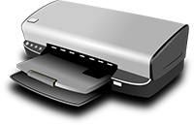

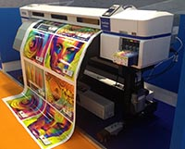
Back to the top of this Panel
Thermal & Laser Printers
Laser printers work by melting toner onto the paper.
They user a powdered toner, not a liquid ink.
The toner is supplied in a cartridge.
They can print in colour but then use 4 toner cartridges - one toner cartridge each for the colours used for printing - which you should remember as being CMYK.
Laser printers are:
A little more expensive to buy
Cheaper to tun and operate
Provide the crispest, clearest text
Are the fastest printers

Thermal Printers
Thermal printers work by burning / heating paper that darkens where heat is applied.
Thermal printers are most commonly seen in credit card machines and cash registers (thats why if you leave your receipt in the sun or expose it to heat it will go black).
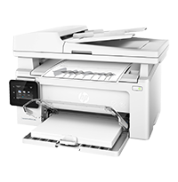
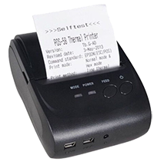
Back to the top of this Panel
Impact Printers
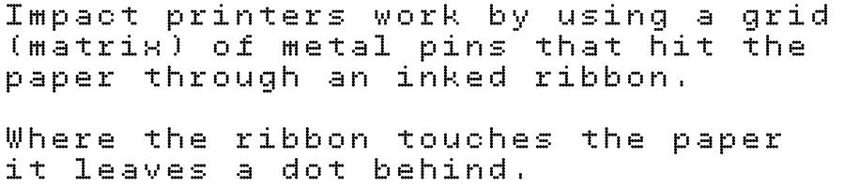
These printers were in common use before Laser and Inkjet printers were invented.
Their one big advantage is that they can make carbon copies as they print.
They can also use continuous feed paper and cost very little to run.
They can print colour if used with a multi-colour ribbon. The ribbon will obviously use the colours CMYK.
They are generally slow, produce low quality output, are noisy and cheap.
They are ideal for use in situations where low cost and reliability are more important than print quality (factories, laboratories, receipt printing, etc.)

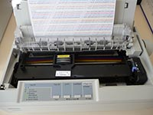
Back to the top of this Panel
Printing and the Environment


Printing and the environment
The first thing we want to say about printers is -
THINK before you use one!
Ask yourself:
Note to self:
Printing is not environmentally friendly!!!
Do I really need to print?
Can I not rather use a digital version of the document - send it by email or on portable storage?
Have I carefully proofread my document on screen - so that I don't have to reprint when I discover errors?

The environmental impact of printing
Producing paper uses a lot of toxic chemicalsthat have to be disposed of in some way
Producing paper also creates foul smelling air pollution (as anyone who lives near a paper mill can tell you).
Producing paper uses a large amount of energy (electricity).
Producing paper uses a lot of water(more per ton of product than any other industry).
Paper (and paper like products) take up a significant amount of space in rubbish dumps.
The trees that are needed for paper consume a lot of water and take up land that could be used for other purposes.
Printers are vampires! People seldom switch their printers off - they are always on standby - waiting and ready to print - and also using power!
On top of this the plantations used for paper tend to be made up on one type of tree (monoculture) which is often non-indigenous. This has a severe impact on wildlife habitat and biodiversity.
If you want to practise Green Computing then you should make an effort to reduce the amount of printing you do!
Choosing a Printer

Tips for choosing a printer

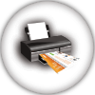
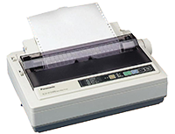
Here are some questions you should ask yourself before buying a printer:
Ask yourself:
Do I need high quality photo / graphic printing?
If you answered YES then you should get an Inkjet printer
How frequently will I use the printer?
If the printer will stand idle for long periods then do not get an Inkjet because it will give trouble - the nozzles will clog.
Which is more important - cost or print quality & reliability?
If you answered quality then get a Laser or Inkjet printer. If cost and reliability matter more, get a Dot Matrix printer
Do I need carbon copies?
If you answered YES then get a Dot Matrix printer
Am I going to print a lot of pages?
If the answer is YES and quality is not important then get a Dot Matrix printer.
If the answer is YES and quality is important then get a Laser printer.
How important is speed?
If speed is very important then get a Laser printer.
Which is more important - initial cost, running cost or both?
If initial cost is important (i.e. is must be cheap) then get an Inkjet or Dot Matrix printer.
If running cost is important (i.e. it must be low) then get a Laser or Dot Matrix printer.
If both are important then get a Dot Matrix printer.
Back to top of Dropdown List
3D Printing

Creating physical objects
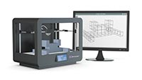
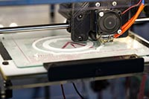
A 3D Printer uses solid materials to create a physical, 3D object.
3D printers are quite amazing in what they can do.
Scientists and companies are coming up with all sorts of things that they can use these printers for.
Prosthetics (hands, feet, paws, flippers, tails) for humans and animals.
Organs (using bio-printing)
Buildings (using concrete)
Aircraft parts - including wings
Tools (including one printed in the space station - cheaper than sending one up by rocket)
Bridges
Food (especially chocolate confections)
And so very much more.
3D printing works by building up an object layer by layer.
This can be done by melting plastic and putting thin layers (thinner than a hair) on top of each other to build the object. You can also use a laser light to harden layers of resin.
Because it works by building up layers 3D printing is also called Additive Manufacturing.
Before you can use a 3D printer you have to create a 3D model of what you want to print on your computer using 3D graphics or CAD software.
3d printers:
Work very slowly - it can take hours or even days to print something
Are finicky to work with and need a great deal of patience and expertise to produce good quality results.
Are also very expensive.
For these reasons 3D Printers are not a common consumer purchase and it will be a while before the general public buys and uses them.
Back to top of Dropdown List
Sound - stimulating a different sense

Output for the ears
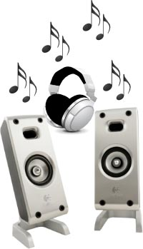
Sometimes your computer needs to catch your attention when you are not looking at the screen - or when you may not be looking at the right place on the screen.
It does this by playing a sound. This is why most alerts and warning dialog boxes pop up onto the screen with a sound.
Sound enriches the user experience and is an essential part of the multimedia environment.
Originally the computer had a very primitive speaker that could only produce simple beeps.
Gamers created a need for better sound and so the sound card was developed as a separate add on.
Today computers have good quality sound cards built into the motherboard with outputs that allow you to connect headphones and speakers and play music, the audio track from videos or even music / sound effects that you create and edit yourself.
The output here is provided by speakers and headphones. These can connect to the computer using:
Headphone Jacks
USB
PCA Jacks
Back to top of Dropdown List
Haptics - Bzzzz Bzzz

Output for the sense of touch
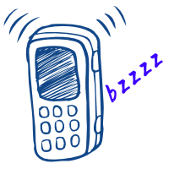
Haptic output is when a device communicates with you through your sense of touch.
This form of output really entered the mainstream consciousness as a way to alert you to your phone getting a call / message when the sound is turned off. The phone would vibrate to get your attention. It communicated with you by touch.
Haptics is used in all sorts of ways - vibration as 'keys' are pressed to make typing on an on screen keyboard feel more realistic, vibration as feedback in games, vibration in response to specific types of touch input (Apple calls this 3D Touch), and so on.
Haptic feedback is also used in most games controllers - but some take it a step further and use more powerful motors to provide 'force feedback' - make the joystick or steering wheel harder to turn when physics would make a real life joystick or steering wheel harder to control.
Back to top of Dropdown List
Computer controlled devices / Robots & the IoT

Output without humans
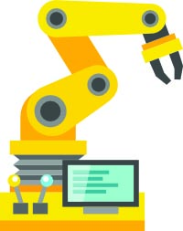
Sometimes the computer creates output not meant for humans.
Communicating with other computers or saving data to storage are examples of output without humans.
This section though looks at when output takes the form of
control signals to other electronics that tell them to do something - like switch themselves on or off.
When the electronics are connected to mechanical devices then the computer control signals can change what the mechanical devices do - making them into robots.
Robots can be controlled:
by humans from a distance (using computers to manage the communication and interpret the human control commands)
by computers following a strict program
by computers that try to sense their environment and respond accordingly (making them autonomous or self-controlled)
by a combination of these methods
The combination of sensors and computer control are making astonishing advances in this field possible. These advances have far greater implications than more efficient manufacturing methods - these include:
Really useful and flexible prosthetics (artificial limbs)
Autonomous robots
Self driving cars
Smart homes
Robotics toys
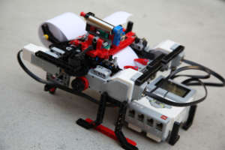
This is a working Braille Printer built using a Lego Mindstorms EV3 Robotics kit.
Image : By Nbanerjee [CC BY-SA 3.0 ], from Wikimedia Commons
and so much more…
A leader in the field is Boston Dynamics.Their
Youtube channel
showcases some of the amazing things their robots can do!
You can also experiment with and program robots. The Lego Mindstorms EV3 set is a good place to start (check it out in the video links). .
You (or your school / class) can even compete in robotics competitions!
Check out the
World Robot Olympiad
and
HandsOnTech
(Learning Opportunities has no association with HandsOnTech, nor has Learning Opportunities received any compensation or consideration for this mention) - the best place for your school to get the Lego robots to work with.
Robotic / sensor driven technology is also part of the whole movement towards the
Internet of Things (IoT)
.
The vision here is that our everyday electronic devices and appliances are equipped with sensors and can be controlled by computer. They are also connected to the internet. These devices can then communicate with us - or with other computers depending on the input they receive.
A typical example here is an IoT fridge that can detect when you are low on milk or cheese (for example) - or if theses items have gone off. The fridge can then either tell you to get these products by sending you a message - or automatically order them from your favourite online shop which will then deliver the products to you.
Back to top of Dropdown List

Video Links - Screens and Projectors
We have selected and curated a set of videos on YouTube related to your course.
These videos are not created or owned by us.
They may display advertising and in some cases may contain limited amounts of swearing.

Video Links - Printing

Video Links - VR & AR

Video Links - Output
We have selected and curated a set of videos on YouTube related to your course.
These videos are not created or owned by us.
They may display advertising and in some cases may contain limited amounts of swearing.

Video Links Hardware - Robots

